Notes for Meet Entry Secretaries
First - read the Meet Information as it can actually be quite useful. Then either download the entry files from the relevant website or send an e-mail to the person taking the entries (details on the Meet Info) and they will e-mail you the file.
Import the file into your Team Manager - does this Meet require accredited times?
Every time you import (or manually enter) a set of results into your Team Manager you should assign the Meet a "Meet Type" for either Accredited , Not accredited or Training so that when accredited times are required you can easily ensure only appropriate times appear on the Eligibility Report and subsequently the entry.
The first thing you have to do is make sure that as you put each set of Meet results into Team Manager that you assign it a “Meet Type”. If you go to any Meet in your database and click on “edit” the Meet set up window will appear. Near the bottom right corner of the window there is a box called “Meet type” – you can either use some of the codes already in there or you can go to “Set up” in the main menu, select “groups/Sub groups/Codes and then you can create your own. Most clubs use Acc for accredited, NAC for not-accredited like L3 meets or Time Trials and Trn for training times. Once you’ve got the codes just go through each meet and give them one of these – if it’s not been done before you only need go back one year with accredited meets as times go out of date after that anyway.
Once they’ve all been identified by meet type go to the Meet set up for the meet you want to enter, make sure “Acc” is in the Meet type box and then click on the Eligibility Rules tab and tick the boxes as explained below and shown in the attached screen shot – age up date and since date should already be filled in so don’t touch those. The system should then indicate that any non accredited times are not eligible by highlighting them in pink as you select the entries for each swimmer.

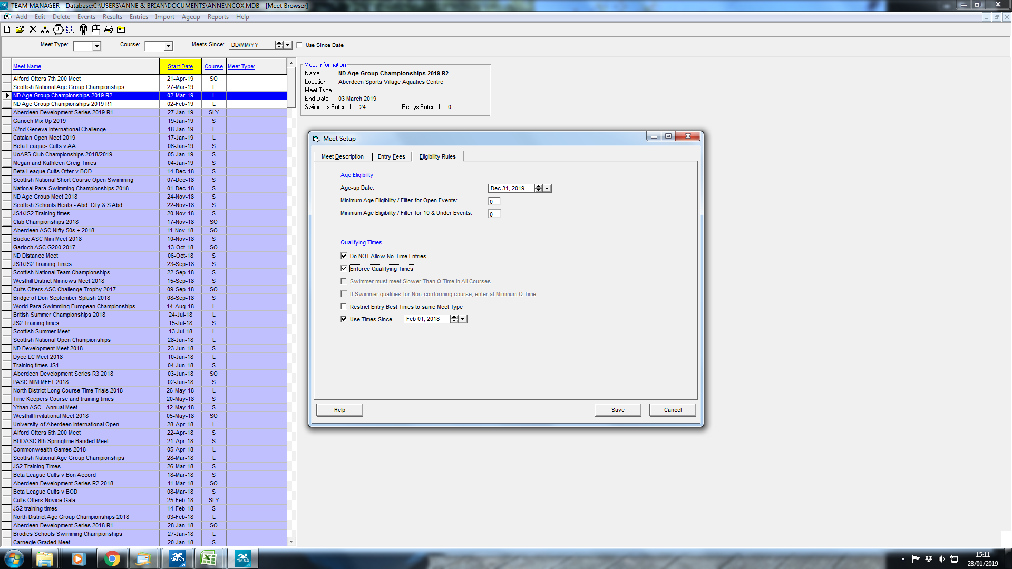

To do this double click on the meet. On the first tab, set the meet type to ACC. Then go to the last tab "Eligibility Rules". Tick the box "Restrict Entry Best Times to the same Meet Type. In the box below should be the "since date" one year before the meet closing date. You also need to tick “Do not allow No Time entries”, “Enforce Qualifying times” and this should help avoid any errors.
Now your Eligibility report should only show accredited times - double check one or two manually to be certain.
Give your Eligibility report to the coach and/or put it on the Club noticeboard, whatever your club procedure for meet entries is. Make sure that you put a deadline on it for entries to be confirmed to you - at least 3 days before the closing date on the Meet Information. STICK TO THIS DEADLINE.
Once you know which swimmers wish to be entered for which events, go back to Team Manager. Check that all the swimmers to be entered are members of SASA and have SASA ID numbers on the database - they cannot compete without these. You can input individual entries by event or by name, but if there are relays they have to done in Entries by event, make sure you have studied the rules for the relays, age, gender etc - in North District events swimmers are NOT allowed to swim up in relay teams.
If you have more than just one Club in your Team Manager database, make sure you have selected the correct Team for this Meet. Work through your swimmers putting in their entries for each event selected. If the Meet has consideration times, whether "faster than" or "slower than" times, these times will show on the right of your entry screen at all times. If the time in front of you is highlighted pink on the screen, then it does not meet the consideration time. Be careful, as entries outwith the consideration times won't be accepted, and may not be refunded either.
Once you have completed all your entries, go to Reports: Entry reports and create a report - you can do this either by Name or by Event. By Name allows you to double check that you have entered all your swimmers for the correct events, but by Event is more useful as this can be exported as a csv file and used later to check the draft programme, as a running order sheet for your coaches on the day and also to ensure that you receive all the correct refunds after the meet if there were rejections.
If the Meet does require accredited times, it is a good idea at this point to also create a Proof of Times report.
Go to the Meet in Team Manager, then Reports:- Entry Reports over in the top right of the window there is a list under Options, and you can tick proof of times report in there. It will then show the Meet and date where the time was achieved on the right hand side of the report. Save as a pdf or rtf file and before sending quickly scan through to make sure there are no obvious mistakes.
If you are happy with the Entry Report then go ahead and create the actual entry file ready to send off once you have completed the remaining paperwork
Now you have completed the process in Team Manager, return to the Meet Information and complete the Summary sheet. Make sure you include any meal passes required for your coaches in your total amount due. If you don't have control of the cheque book, you need to request a cheque from the Club treasurer - this is where the 3 day before the closing date deadline becomes important. * A lot of Clubs now pay by BACS, you may need to request the Bank details for the Host Club so your Treasurer may still need the extra days.
While some clubs will now accept the paperwork by post after the closing date, it's good practice to get the cheque and summary sheet in the post as soon as possible, and no later than the closing date - your own club may be running a Meet some day and they will want the entry fees in on time.
Once the paperwork is completed and everything matches up e-mail your entry file and your proof of times report if applicable to the person taking the entries. You may or may not get an acknowledgment of your entry, but if you don't receive an acknowledgment then if you haven't received the draft programme by the following Thursday it's worth checking to see if your entry arrived safely. Your cheque if posted on time acts as an alert to the person taking the entries, should they not have received your entry file by e-mail - another reason for getting it away on time.
When you receive the draft programme check through your entry by event report and make sure that all your swimmers have made it on to the draft - mistakes do happen. Make a note of any reserve or rejected swimmers so that you can verify the refunds after the Meet. Advise your coach and swimmers of accepted/rejected swims.
Withdrawals - there are always some of them. Notify the club running the Meet as soon as possible and again mark these on your entries by event report - you don't get refunds for withdrawn swimmers but the coach on the day needs to know which swimmers to expect on poolside.
Read the Meet Information again for information on marshalling and withdrawals, North District meets require withdrawals by a certain time and swimmers can be fined if they fail to appear for swims or don't withdraw in time - make sure parents are aware of this as well as coaches.
After the Meet, you may be sent the results file by e-mail or it may appear on the relevant website, check that there are results for all the expected swimmers, mistakes can happen especially if there have been reserve swims. Check the refunds in due course.
Another thing you will likely need to do at some point is enter a swimmer from another club into your database or send the times for one of your swimmers to their new club.
Transferring Athlete results between Clubs
The transferring out Club should send the new Club an exported results file for each swimmer moving.
To do this go to Athletes in Team Manager and select the swimmer:-
then go to Results:- put a "since date" of one year ago in the box (see screenshot) and then tick the "Use Since date" box below. Untick "Fastest" as there may be slower but newer accredited times available. This will pick up all current results, then click on "Export Results" at top and note where the export file is being saved to.
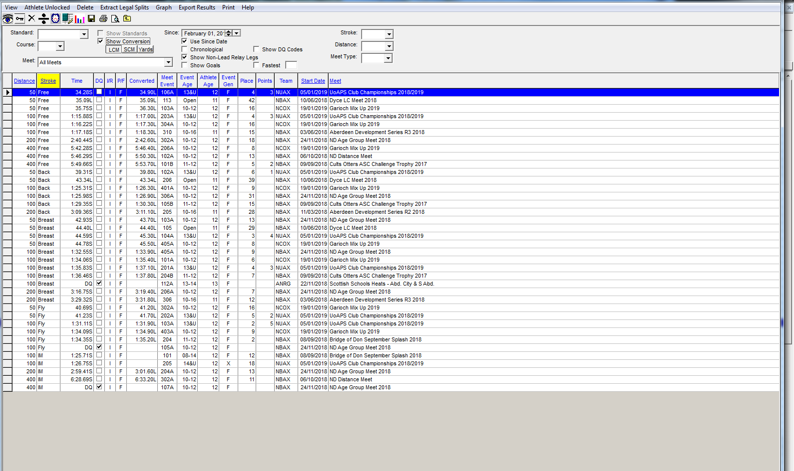
Repeat for all swimmers transferring and then e-mail the result files to en new club.
When the new Club receives the file(s) simply import as if it were a normal Meet Results file. But first ensure that the transferred swimmer has already been entered into your Team manager database with the correct date of birth and SASA ID number.
If you already have some results entered into your database for the swimmer you may get an Exception report with Duplicate results but you can ignore this. Once the file has been imported you should be able to see all the times by going to Athletes:- Results and selecting the swimmer and the correct meets and dates will be showing which means Proof of Times reports will be accurate in future.
