Inverness Amateur Swimming Club

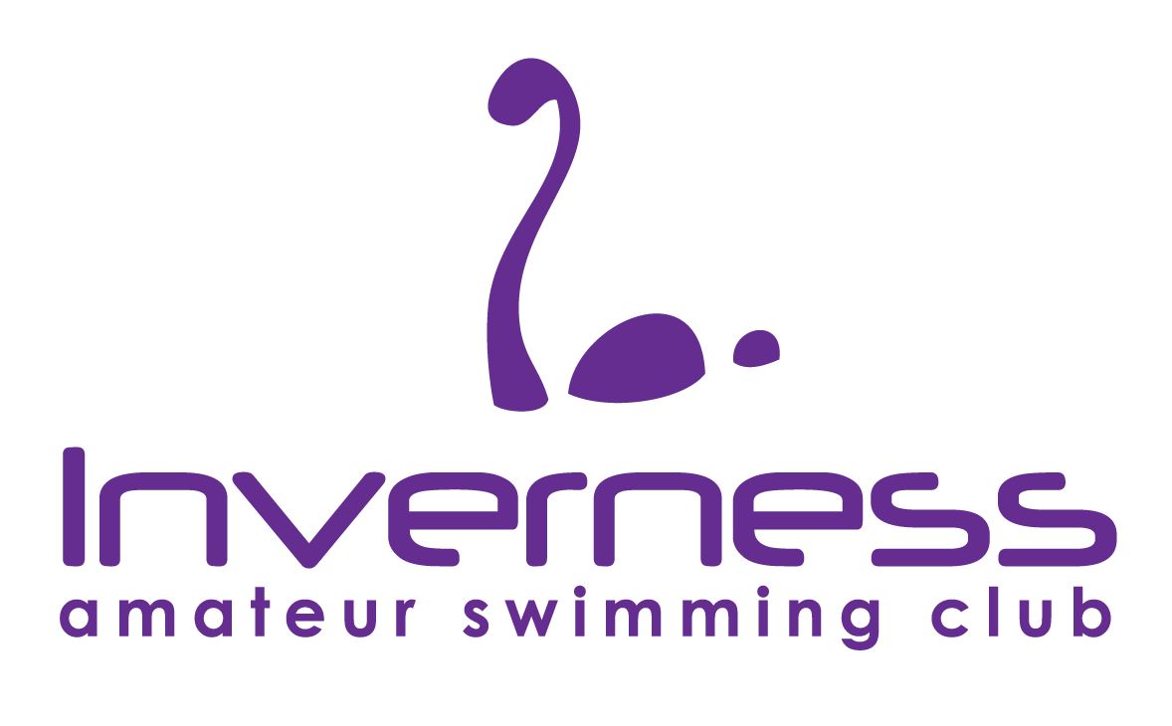

Graded Meet

INVERNESS AQUADOME SWIMMING POOL
On
28 March 2026

Licence Number : L2/ND/032/MAR26

MEET INFORMATION
(UNDER WORLD AQUATICS AND SASA SWIMMING REGULATIONS)
POOL | 25 Metres, 8 Lanes, Anti-turbulence ropes, Starting Blocks deep end, Electronic Timing. 2 metre depth both ends
SESSIONS | Session One Warm Up 08.45 - Start 09:50  Session Two Warm Up 13:30 - Start 14:35  (SUBJECT TO CHANGE IF NECESSARY)
EVENTS  RELAYS | AGE GROUPS  8-10 years - 50m individual stroke swims  11-14yrs – 100m individual stroke and IM swim  Please see attached sheet for order of events. All events are heat declared winners.  All members of the relay team(s) must have taken part in at least one individual event in that session. A maximum of two relay teams per event per club. Swimmers must swim in their respective age groups. Team lines will be required one hour before the start of the session in which the relay takes place.
AGE | Age on last day of competition: 28 March 2026  Age Groups are: 8-10 years, 11-12 years & 13-14 years
MEDALS | Medals will be presented to 1st, 2nd and 3rd place. Speeding certificates and swim caps will be awarded to swimmers who exceed the qualifying entry times (usually by 5% faster than the attached qualifying times). Medals to be collected from the medal table at the top of the spectator area.
ENTRY FEES | £8.00 PER INDIVIDUAL EVENT , £10.00 per RELAY TEAM  Entry fees to be paid by BACS to: A/C no: 10466360 Sort Code: 80 91 26  Please include your club’s name in your payment reference.  Please note the entry file and summary sheet must be received by email, along with payment made by BACS transfer, by the closing date.  CLOSING DATE FOR ENTRIES IS 5pm on FRIDAY 6th MARCH 2026
REFUNDS & WITHDRAWALS | Withdrawals from swimmers prior to the competition should be emailed to IASCEntries@gmail.com to arrive no later than 3pm on Thursday 26 March 2026. Withdrawals after this time should be submitted at the recorders desk prior to the start of each warmup using issued withdrawal forms.  Withdrawals through illness or injury will be granted only if the swimmer has been withdrawn in time according to the meet information and when the swimmer can provide medical evidence confirming that they are unfit to swim. Information must be emailed to the Meet Convener (iascconvenor@gmail.com) within 7 days following the meet. The letter should be dated no earlier than the closing date for the meet and not more than 2 days after the meet.  Fees for rejected entries will be returned as soon as possible after the event.
MEET ENTRIES | This is a club meet, and entries will not be accepted from composite teams.  All entries must be on Hy-tek Team Manager entry file by Friday 6 March 2026  Entry files may be obtained by downloading from Swim Scotland, North District website (www.sasanorth.org.uk), or by contacting Meet Convenor iascconvenor@gmail.com  Entries must be submitted using the most up to date personal best times for all swimmers at time of entry. Times to need to be accredited but should be real times. Swimmers entered with No Time (NT) will be rejected.  Entries may have to be limited dependent upon numbers received. If there is an oversubscription, entries will be accepted fastest first as evenly across the programme as is practical. Inverness ASC reserves the right to fill empty lanes with their own swimmers.  Clubs will be notified of any rejected swims prior to the meet along with a provisional program.  This is a graded “ slower than” meet; entries will be accepted fastest to slowest.  A signed Summary Form must accompany all entries.  The organising committee retains the right on the final selection for the number of heats per event. A list of accepted participating swimmers and a draft programme will be emailed to each club.  Please email the entry file and summary sheet to IASCEntries@gmail.com

MARSHALLING | Marshalling will take place at poolside. All swimmers including reserves must attend marshalling before their events and are advised to attend in good time. (The suggested minimum is 4/5 heats or 1 event in advance.)  The start of a race will not be delayed for absent swimmers. If a swimmer is not present when the heat leaves for the final marshalling point, the reserve will swim.
TECHNICAL OFFICIALS | Your club list of Technical Officials should be submitted by email to iascsto@gmail.com by Friday 13 March 2026.  Each club should provide a minimum of 1 Judge and there is an expectation that number of officials provided should be reflected by number of swimmers entered to ensure the meet will be accredited.  Judges and Timekeepers in training, who are requiring specific signatures, should make this clear in their request. Requests will be accommodated only if the referee considers it practical.
CATERING | A light lunch will be provided for all Technical Officials. at a nearby local venue. Technical officials are advised to bring their own water bottles and pens to the event.  Lunch tickets for coaches are available at a cost of £11. Clubs wishing to purchase tickets should complete this section of the Entry Form Summary sheet.
PHOTOGRAPHY/MOBILE PHONES | Anyone wishing to use photographic equipment for non-commercial purposes, including video cameras must complete a Photography Permission Form that shall be available at the meet information desk and wear a wrist band.  It is not permitted to take photos or videos including those acquired on mobile phones unless a Photography Permission Form has been completed. The IASC team will challenge any person not displaying an approved permission wrist band.  No flash photography is permitted at any time within the competition pool area.  Mobile phones may not be used in the pool hall or in the changing rooms.  Any individuals wishing to post images on social media should ensure that only their swimmer is identifiable unless permission has been obtained from the individuals or their parents/guardian.
MEET REGULATIONS | No guarantee can be given by Inverness ASC that the event will take place at a particular time, or any date, and Inverness ASC reserves the right to reschedule the event without notice and without liability for so doing. It is expected that this would only happen because of unforeseen circumstances, e.g., venue/facility failure or adverse weather.
 | In the event of postponement, cancellation or abandonment of the event, refunds if any, will be made at the absolute discretion of Inverness ASC. Inverness ASC will have no legal liability to make a refund or to pay any form of consequential or indirect damage such as loss of enjoyment, travel, and accommodation costs.
Data Protection | Personal data acquired from competitors to allow for the operation of this meet will be held securely and used only for the purpose of managing the meet, including the reporting of results, in line with GDPR guidance.
Technical Swimsuits | As of 1st September 2022, new regulations have come into force regarding technical swimsuits. All swimmers aged 13 years and under cannot compete wearing technical suits in Scottish Swimming licenced or registered events. For further information and FAQ’s please see link below. https://scottishswimming.com/news/technical-swimsuit-policy-update/
Transgender and non-binary policy | From 1 January 2024 the Scottish Swimming Transgender & Non-Binary Competition Policy was implemented nationally across all aquatics sports. The policy and FAQs can be found HERE. Any policy related matters that arise during the event should be reported to and will be recorded by the Meet Convenor/Lead Referee and these matters will be communicated to and managed post event by the relevant Scottish Swimming Staff. At no point will members be challenged on the day of a competition with any matters being resolved post event.  As a result of this policy being implemented, any competitor intending to compete within the Female category at this event will be required to provide confirmation that their birth sex is female when signing up to the meet conditions through entry. By entering the Female category, athletes are therefore confirming their birth sex is female and are eligible to compete in the Female category.
NOTES | All swimmers entered must have paid their SASA membership fee for the current year. Registration numbers must be shown on entry files. A licence has been granted for this competition and accreditation will be applied for to the SASA North District.
 | All participants should adhere to the Scottish Swimming Code of Ethics and relevant codes of conduct.
 | Poolside access will be limited to one Coach per 10 swimmers, with a maximum of 3 Coaches/Team Manager at any one time.
 | Spectating is available but may be limited. There are vending machines around the facility. There is also a café across from the pool at Inverness Botanic Gardens.
 | Participating clubs will receive one copy of start sheets and results will be posted at the pool during the events and after the event on the North District website.
 | Inverness ASC reserves the right to amend the programme at any time.
 | Lockers provided in the changing rooms (free) should be used to store all belongings. The meet organisers and the facility management cannot be held responsible for items lost during the event.
 | Seating areas will be allocated to each team. Teams are responsible for clearing their seating area of belongings, litter etc. before leaving at the end of the competition day.

ENTRY CONSIDERATION TIMES
Swimmers must be equal or slower than the times detailed below:
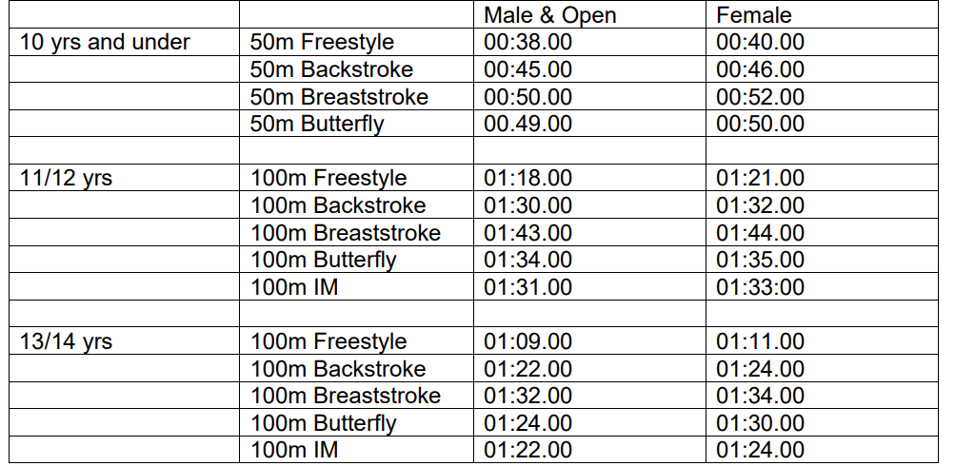

INVERNESS ASC GRADED MEET 2026 - PROGRAMME OF EVENTS

SESSION ONE WARM UP 09:00 START 10:05
Event No | 101 | Males & Open | 11-14 years | 100m Backstroke
 | 102 | Females | 11-14 years | 100m Backstroke
 | 103 | Males & Open | 10 years & under | 50m Breaststroke
 | 104 | Females | 10 years & under | 50m Breaststroke
 | 105 | Males & Open | 11-14 years | 100m Freestyle
 | 106 | Females | 11-14 years | 100m Freestyle
 | 107 | Males & Open | 10 years & under | 50m Butterfly
 | 108 | Female | 10 years & under | 50m Butterfly
 | 109 | Males & Open | 11-14 years | 100m IM
 | 110 | Female | 11-14 years | 100m IM
 | 111 | Male & Open | 11-12 years | 4 x 50m IM Medley Relay
 | 112 | Female | 11-12 years | 4 x 50m IM Medley Relay
 | 113 | Male & Open | 13-14 years | 4 x 50m IM Medley Relay
 | 114 | Female | 13-14 years | 4 x 50m IM Medley Relay

SESSION TWO WARM UP 14:00 START 15:00
Event No | 201 | Males & Open | 11-14 years | 100m Breaststroke
 | 202 | Females | 11-14 years | 100m Breaststroke
 | 203 | Males & Open | 10 years & under | 50m Freestyle
 | 204 | Females | 10 years & under | 50m Freestyle
 | 205 | Males & Open | 11-14 years | 100m Butterfly
 | 206 | Females | 11-14 years | 100m Butterfly
 | 207 | Males & Open | 10 years & under | 50m Backstroke
 | 208 | Female | 10 years & under | 50m Backstroke
 | 209 | Male & Open | 10 year & under | 4 x 50m Freestyle Relay
 | 210 | Female | 10 year & under | 4 x 50m Freestyle Relay
 | 211 | Male & Open | 11-12 years | 4 x 50m Freestyle Relay
 | 212 | Female | 11-12 years | 4 x 50m Freestyle Relay
 | 213 | Male & Open | 13-14 years | 4 x 50m Freestyle Relay
 | 214 | Female | 13-14 years | 4 x 50m Freestyle Relay

Inverness ASC Graded Meet 28 March 2026

SUMMARY SHEET

Contact Details

Club Name/Abbreviation:

Match Secretary Name:

Email:

Contact No:

Address:

Post Code:

Individual Age Group Male & Open Entries | …………… | @ £8.00 | = £…………
Individual Age Group Female Entries | ………… | @ £8.00 | = £…………
Relay Entries | ………….. | @ £10.00 | = £…………
Coach Lunch voucher | …………… | @ £11.00 | = £…………
 |  | TOTAL | = £…………

CLOSING DATE FOR ENTRIES IS 5PM ON FRIDAY 6th March 2026

Payment by BACS transfer to A/C no: 10466360 Sort Code: 80 91 26 – with reference as your club’s name prefix.

Club bank details for refunds: A/C no: …………………… Sort Code: ………………….

Declaration (This declaration must be completed by all competing clubs)

I confirm that all swimmers entered in this competition have paid their current SASA membership fee.

I confirm that all club volunteers’ poolside has appropriate PVG and are CWPS trained.

Signed ___________________________ Position in Club__________________________

Date ___________________________

Entry form to be emailed to IASCEntries@gmail.com

Inverness ASC Graded Meet 2026
Saturday 28th March 2026- Inverness Aquadome Pool
CLUB:
STO CONTACT:
EMAIL ADDRESS:
CONTACT NO:
OFFICIALS SHEET
 |  | Mentoring |  |  | Timekeeper Signatures Required? |  | Sessions Available
Name | Qualified Level | Required (Y/N) | Trainee Level | Any Specific Duties Required (e.g., CIT, Finish Order) | Timekeeper  (Y/N) | Chief Timekeeper  (Y/N) | 1 | 2 | 3 | 4

Any dietary requirements for Technical Officials/Coaches…………………………………………………………….
Please email this form by Friday 13th March 2026: - iascsto@gmail.com

