Results to Rankings

Background
Discussions with the rankings team have been taking place around the automatic loading of results to rankings. This is to allow results to be loaded to onto rankings in a timely manner.

This was trialled at SNAGS. The results appeared within 2 hours of being loaded and the times were included in the Summer Meet list produced on the Tuesday after SNAGS. The process was again trialled at the Open meet and again worked very well.

Concerns were raised from Swim Committee around the times being loaded to rankings;
- What would happen if the time was loaded incorrectly
- If a session wasn’t licensed and the times had been loaded
- If there were other errors and times didn’t load

This would be no different as to what happens now, if any errors are spotted or session not licensed, an email would be sent to rankings and the times would be corrected or pulled. If results were loaded and some did not load, rankings would email the person assigned to load the results.

Results should only be loaded once the licence has been signed by the referee. Instead of emailing Rankings the result file this can be loaded directly.

Just now rankings still accept the emails with results and load these to rankings. Moving forward and if we don’t move to the automated system then results may take longer to load due to staffing.

The aim is to have level 1 and 2 licensed meets results being uploaded via this system by January 2025.

Rankings are happy with the tests carried out for the uploading of results for the two Scottish National Event results this year and are now ready to carry out tests on club events. Sean Dawson, North Licencing Convenor has agreed to help with the testing of the loading of club events and these will be carried out in the next couple of months. If this process works then it will be rolled out to clubs.

The following document gives details of the process and stages from the license submission and approval to the uploading of results to rankings.

Prior to the Event
Licence Application
The licence application for meets has not changed and should be submitted as normal to the district licence convenor.

District Licence Convenor
Process the licence application as normal. For approved level 2 licenced meets, send details of the approved licences to rankings, this can be done once a month to rankings rankings@swimming.org with the following information:

Applicants contact details (Meet Promotor):
Name
email address
Telephone
Name of organising club
Name of Meet
Date of Meet
Venue Name
Venue town/city
Pool length

Meet Promotor
The process for applying for a licence and this being approved has not changed. For approved level 2 licences, the district licence convenor will send your event and contact details on to rankings. Once the rankings process the meet, an email will be sent from Swim England (communications@swimming.org) to the email address you have provided. Keep this email safe, until the meet.
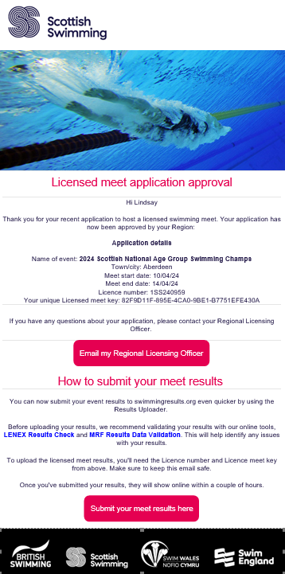

Process after the event
Uploading results

The following files should be requested from whoever is running Meet Manager
- PDF of the results, this can be per session or full meet
- hdr per session
- mrf per session

save the files to your device.

Open up the email sent from Swim England. Click on MRF Results Data Validation and follow the instructions to check for any errors. Once you are satisfied the file is correct, click submit your meet results here. A window will pop as follows Using the licence number and the unique licensed meet key provided by Swim England, login to the results portal.

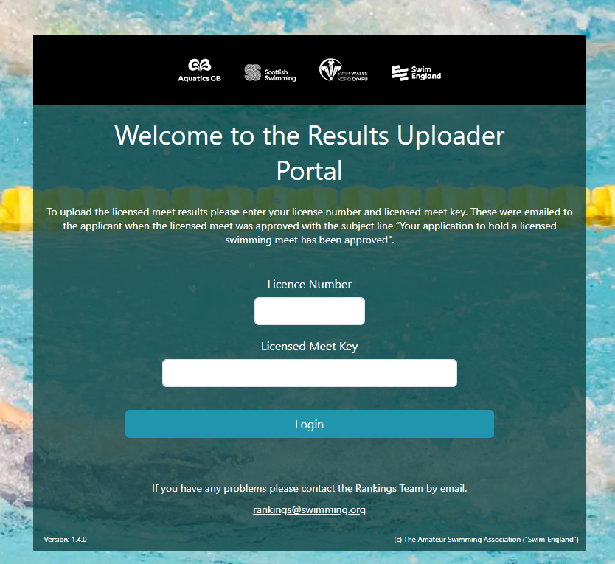

You are now in the portal, If the details are correct, click next. If not, do not proceed and email rankings@swimming.org

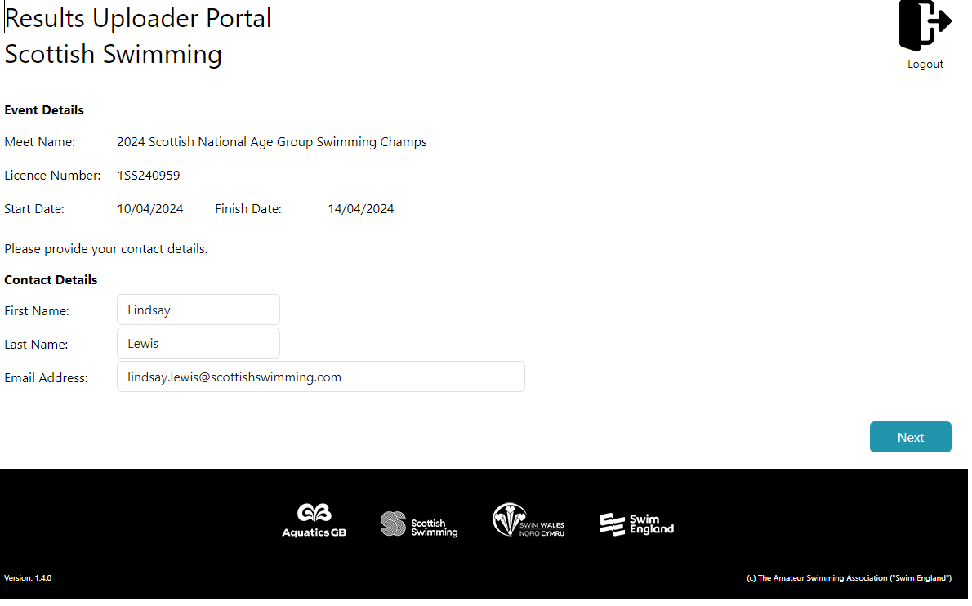

The first file to be uploaded is the PDF of the full results. Select the PDF results file you have saved to your device to be uploaded and then click upload

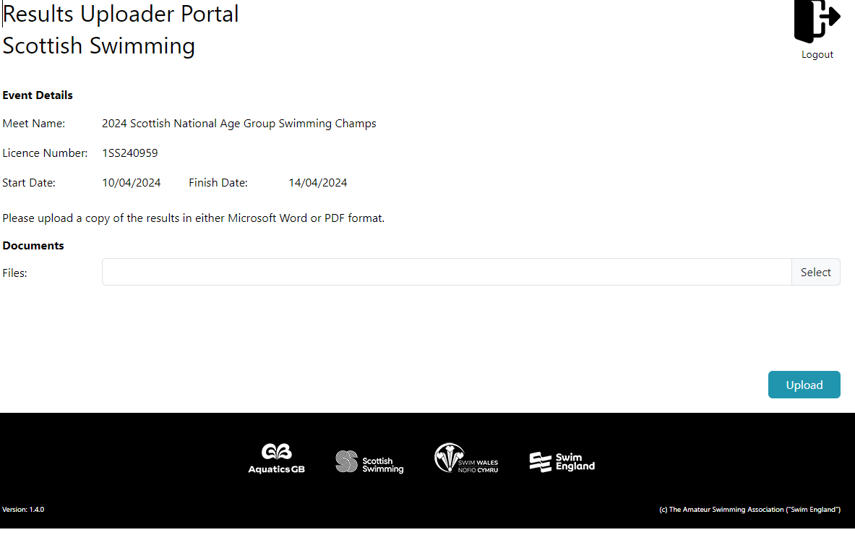

Once the file is uploaded, you will then be taken to the next page

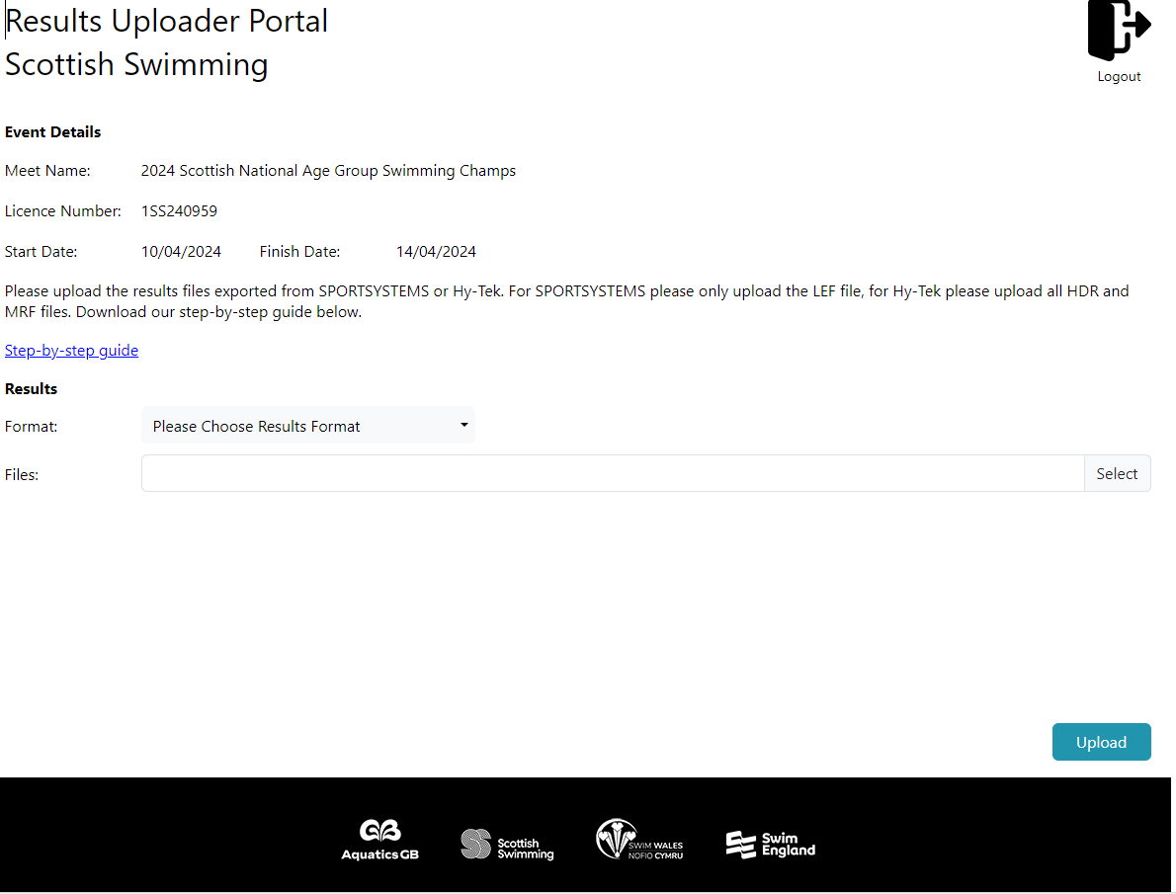

Format: select Hy-Tek select Neutral Data Format from the drop-down menu

Files: select the hdr and mrf files for each session from the files saved to your device then click upload
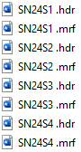

More than one session results can be loaded at one time.

Once this is completed, the web application can be closed.

Shortly after the upload, you will receive an email:
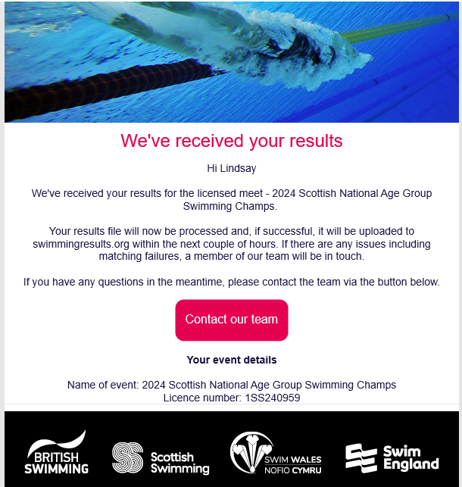

Once this email is received you should then receive another email similar to below (this may take around 30 minutes)

Results failed with minor failures
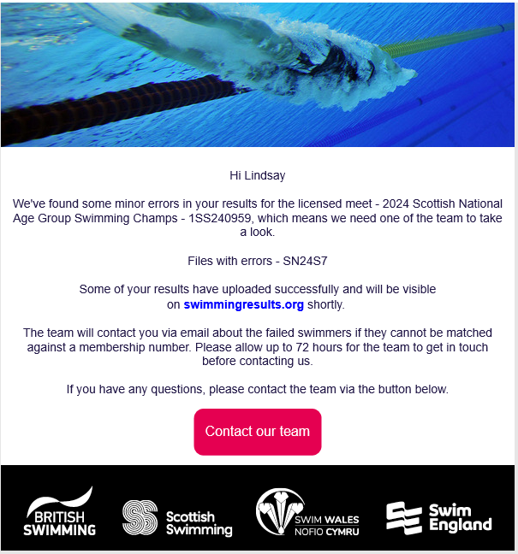

If the results are not accepted, a member of the rankings team will be in touch via email within three working days to resolve the issues.
This could be an issue with the exported files and they may need you to export the files again.

