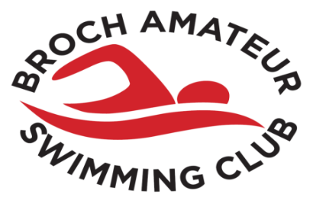
MAYDAY MADNESS 2025
SUMMARY & DECLARATION SHEET
CLUB NAME/ABBR
MEET SECRETARY:
ADDRESS:
TELEPHONE NUMBER:
EMAIL:

______ Mixed 50m Male/Female Entries @ £6.00 ________  ______ 100m & 100IM Male Entries @ £7.00 ________  ______ 100m & 100IM Female Entries @ £7.00 ________  ______ 8x50 Mixed Relay Entries @ £8.00 ________  ______ Coaches Meal Pass @ £6.00 ________ | Paperwork and Payment must be received within 3 postal days of closing date (4th April 2025).  Please ensure you have enclosed the following;  BACS, Hy-tek TM Entry File & Summary Sheet
Total: £________

PAYMENTS VIA BACS Account No: RBS Broch ASC A/C 00574024 Sort Code: 80-06-86
FOR REFUNDS AFTER MEET
CLUB A/C NAME:
SORT CODE: BANK ACCOUNT NUMBER
Payment Reference MM25 followed by your club code e.g. MM25NBHX.

DECLARATION: I confirm that all swimmers entered in this competition have paid their current SASA Membership fee.
I confirm that all Coaches and/or team staff from our Club who will be on poolside are members of Scottish swimming and have current PVG Disclosure.
Signed:
Position in Club: Date:
(This declaration must be completed by all Clubs)

